## Thresholding

Thresholding works by running through the different intensity levels of the image and iteratively taking the average. Then the image is split into a binary image of that above and that below the calculated threshold. This works well for differentiating images where the region of interest is in a very different intensity level then the surrounding image.



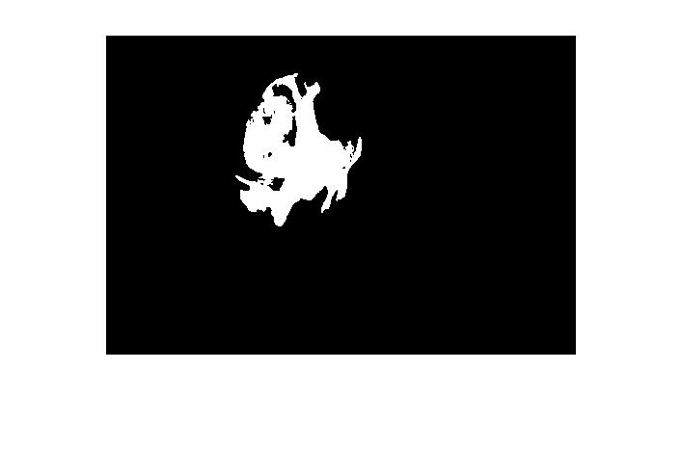

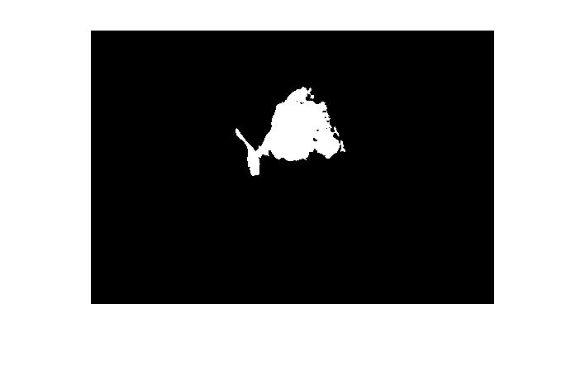

## Segmentation

The first part of segmentation is to manually apply thresholding to the image to isolate the higher intensity levels. Then applied edge detection to the image and further filtering. Then since the tumor is assumed to be the largest part of the brain with distinct edges it is then isolated and filled in white while having the rest of the image black. This works for this image as the portion we are trying to isolate for is the largest portion and high intensity on the inside.



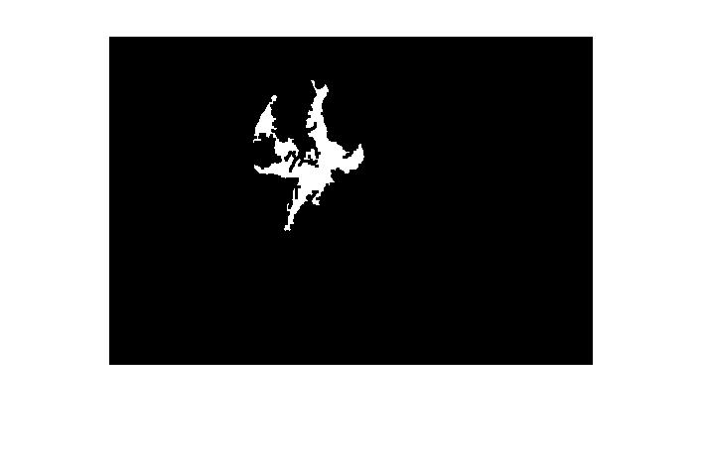



## Clustering

K means clustering works by finding center K points at various intensity levels and then clustering the similarly valued pixels. The image is then segmented into regions with all similar values in order to isolate unique region all with similar values of intensities.



